**Extended Abstract/Full Paper Template for CECAR 8 (Title)**

Shinji SATO1, Gaku SHOJI2, and Yukihiro TSUKADA3

1 Professor, Department of Civil Engineering, The University of Tokyo, Tokyo, Japan

(Email: sato@coastal.t.u-tokyo.ac.jp)

2 Associate Professor, College of Engineering Systems, University of Tsukuba, Tsukuba, Japan

3 Executive Director, Japan Society of Civil Engineers, Tokyo, Japan

**ABSTRACT:** An extended abstract or a full paper should be prepared in the same format as follows: (1) Limits on the length of an extended abstract is up to 2 pages and of a full paper is up to 15 pages, (1) Use A4-size sheets, (2) Use 14-point Calibri bold for title, (3) Use 12-point Times New Roman for author’s names and affiliations, (4) Title, author's names, and affiliations should be centered, (5) Insert one blank line between the affiliations and the main text, (6) The Abstract should be 300 to 500 words long, and (7) Use 11-point Times New Roman for the Abstract and the main text.

**1. HEADINGS (INDENT LIKE THIS SAMPLE IF IT IS LONG)**

**(1) Main heading**

Capital letters in 12pt bold face fonts should be used for main headings (chapter titles) that follow the chapter numbers as is shown in this example.

**(2) Sub-headings for sections**

The sub-headings for sections, in 11pt bold face fonts, with their initial letters capitalized, are preceded by parenthesized section number like **(2)**.

**a) Sub-headings for sub-sections**

They are written just as the sub-headings for sections are done, but follow alphabets with right parentheses. No spacing of lines is left before and after every sub-heading.

**2. MATHEMATICS**

Use special high quality fonts for all mathematical equations in the text. Some equations may be placed off the text as:

 (1a)

 (1b)

and some appear in the text as *CD*, (*z*). Numbered equations ((1a) and (1b) for example) should be center-aligned. The equation numbers in parentheses should be placed flush right.

**3. FIGURES AND TABLES**

**(1) Location of figures and tables**

Figures, tables and photographs should be inserted at the upper or lower part of the page where reference is first made to them. Do not place them altogether at the end of the manuscript. Do not place any text besides figures or tables. Insert about one to two lines spacing above the main text.

**Table 1** Statistics summary

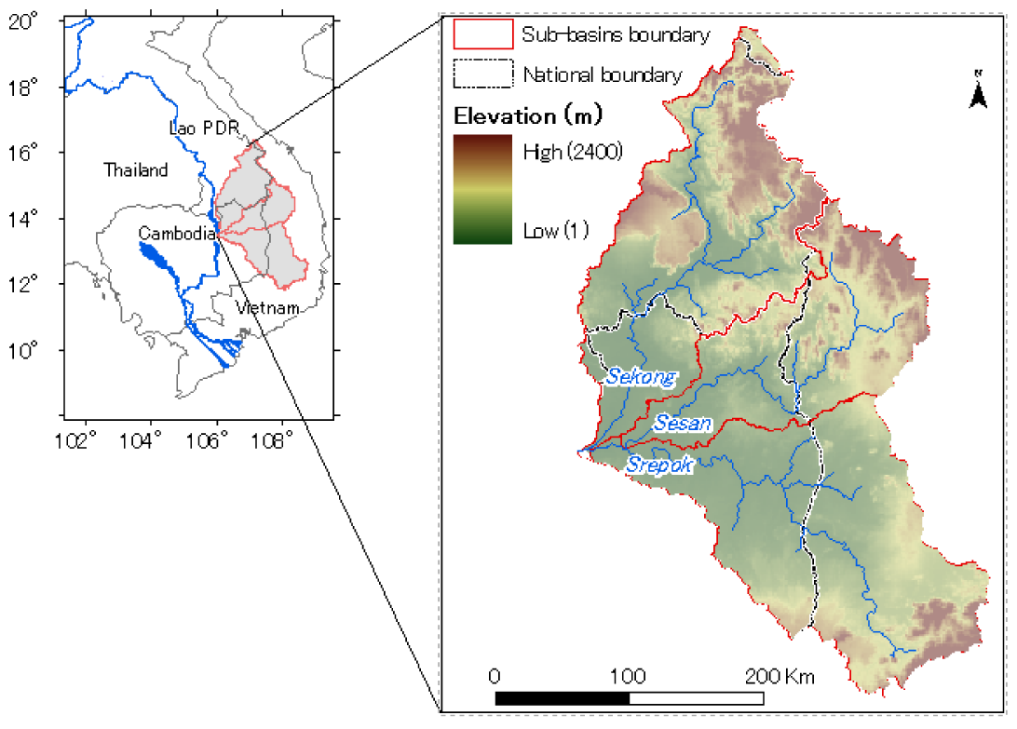

**Fig. 1** Study area

**(2) Fonts and captions**

Do not use too small characters in figures and tables. At least, the letters should be larger than those in the captions (9 pt). Captions should be centered like an example of **Fig. 1** and **Table 1**. The heading of captions is 11pt bold face.



**4. CITATION AND REFERENCE LIST**

All the references must be numbered in the order of appearance in the article and the right parenthesized numbers are used at the text where it is referred like this1). The reference list must be summarized at the end of the main text. The reference list is followed by the date of acceptance with one line spacing between them as shown in the present sample.

**5. CONCLUSIONS**

**ACKNOWLEDGMENT:** Acknowledgment should follow Conclusions.

**REFERENCES**

1. Miles, J. W. : On the generation of surface waves by shear flows, *J. Fluid Mech.*, Vol. 3, Pt. 2, pp. 185-204, 1957.
2. Miche, M. : Amortissement des houles dans le do-maine de l’eau peu profonde, *La Houile Blanche*, No. 5, pp. 726-745, 1956.
3. Gresho, P. M., Chan, S. T., Lee, R. L. and Upson, C. D. : A modified finite element method for solving the time-dependent incompressible Navier-Stokes equations, part 1, *Int. J. Numer. Meth. Fluids*, Vol. 4, pp. 557-598, 1984.
4. Shepard, F. P. and Inman, D. L. : Nearshore water circulation related to bottom topography and wave refraction, *Trans. AGU.*, Vol. 31, No. 2, 1950.
5. Smith, W. : Cellular phone positioning and travel times estimates, *Proc. of 8th ITS World Congress*, CD-ROM, 2000.
6. Ministry of Land, Infrastructure and Transport, Record of the Great East Japan Earthquake-Disaster Response, Mar 11, 2012. Available on Mar 7 2018: http://www.mlit.go.jp/common/000208803.pdf

(Accepted as of Sept. 30, 2018)