**Abstract Template for CECAR 8 (Title)**

Shinji SATO1, Gaku SHOJI2, and Yukihiro TSUKADA3

1 Professor, Department of Civil Engineering, The University of Tokyo, Tokyo, Japan

2 Associate Professor, College of Engineering Systems, University of Tsukuba, Tsukuba, Japan

3 Executive Director, Japan Society of Civil Engineers, Tokyo, Japan

**ABSTRACT:** A one-page abstract should be prepared in the following format: (1) Use a sheet of A4 size. (2) The main text of the Abstract should be 300 to 500 words long. (3) Figures and tables can be inserted. (4) Use 14 points bold Calibri for title. (5) Use 12 points Times New Roman for author’s names and affiliations. (6) Title, author's names, and affiliations should be centered. (7) Insert one blank line between the affiliations and the main text. (8) Use 11 points Times New Roman for the main text. Main text should be fully justified with a single spacing. (9) The Abstract file should be in PDF format. (10) Deadline for submission is 28th February 2018.

Table 1 Statistics summary

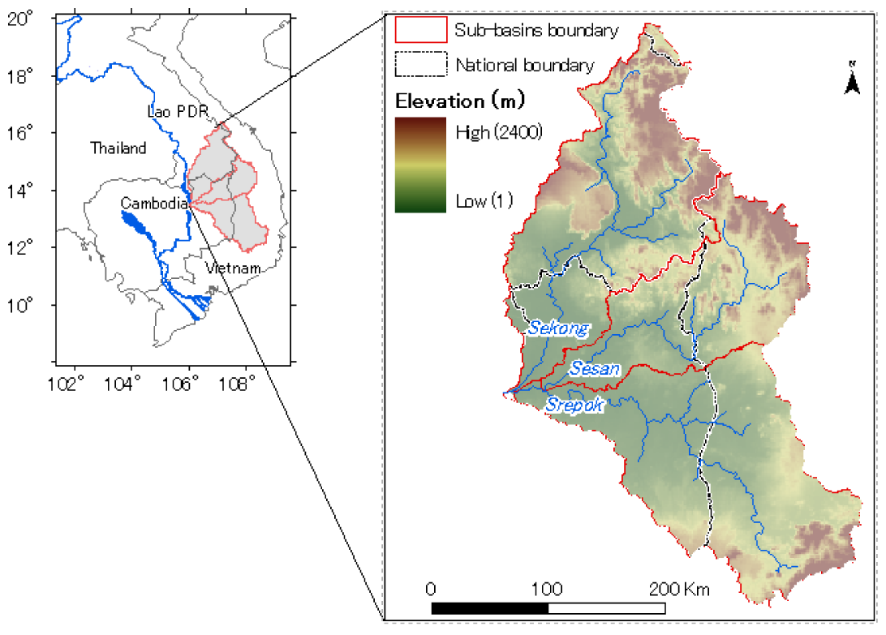

Fig. 1 Study area

